LAB 5

1. create table employeee as select * from emp where 1=3;

desc employeee;

select * from employeee;

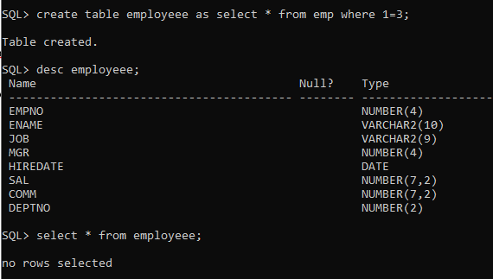

2. insert into employeee(empno,ename,sal,deptno) select empno,ename,sal,deptno from emp;

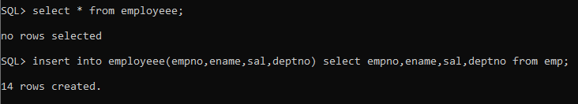

3. update employeee set job=(select job from employeee where empno=7788),deptno=(select deptno from employeee where empno=7788) where empno=7698;



4. delete from department1 where dept_name = ´sales´;



5. update employeee set deptno=(select deptno from employeee where empno=7698) where empno=7788;



6. insert into employeee values(&empno,&ename,&job,&mgr,&hiredate,&sal,&comm,&deptno);

Enter value for empno: 1000

Enter value for ename: ´allen´

Enter value for job: ´clerk´

Enter value for mgr: 1001

Enter value for hiredate: ´12-Jan-2001´

Enter value for sal: 3000

Enter value for comm: 2

Enter value for deptno: 10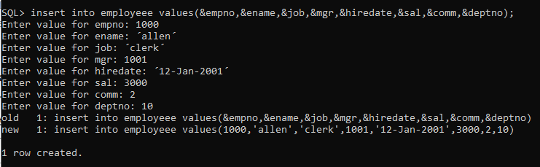

Lab 6

1. insert into customer_masters values(&customer_id,&customer_name,&address,&gender,&age,&phone_no,&income);

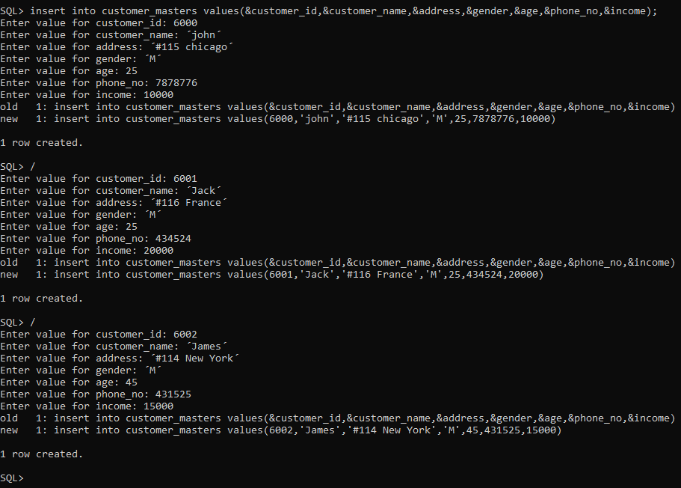

1. savepoint sp1;

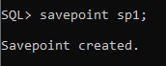

1. insert into customer_masters values(6003,'John','#114 chicago','M',45,439525,19000);



1. rollback to sp1;

